BUHLER’S MID-SUMMER ROUND UP

A chance to share with you some recent events and current prayer requests.
I have a longstanding friendship with a single mum and her children in our neighbourhood. One time she sought spiritual deliverance from terrible dreams she and her children were facing. Ultimately she chose to continue offering food to her deity in her bedroom shrine but we remained friends. Her oldest child came to Sunday school once and declared that there was a God and His name was Jesus. However there was no opportunity to continue coming until recently when they heard about our summer camp and both were able to come subsidized through Mark’s recycling efforts “Cans for Campers. (to date over $250 has been earned). Now it is wonderful to see both her children and 50+ others singing songs about Jesus in preparation for a concert for the parents this Friday night. The mum is clearly happy and has promoted the camp to her neighbours who also come from different faiths. It is quite an exciting and energy filled time in the church. Two of our grandchildren are attending and singing the songs in their home. I have so enjoyed the little part I have played in this community service and outreach.
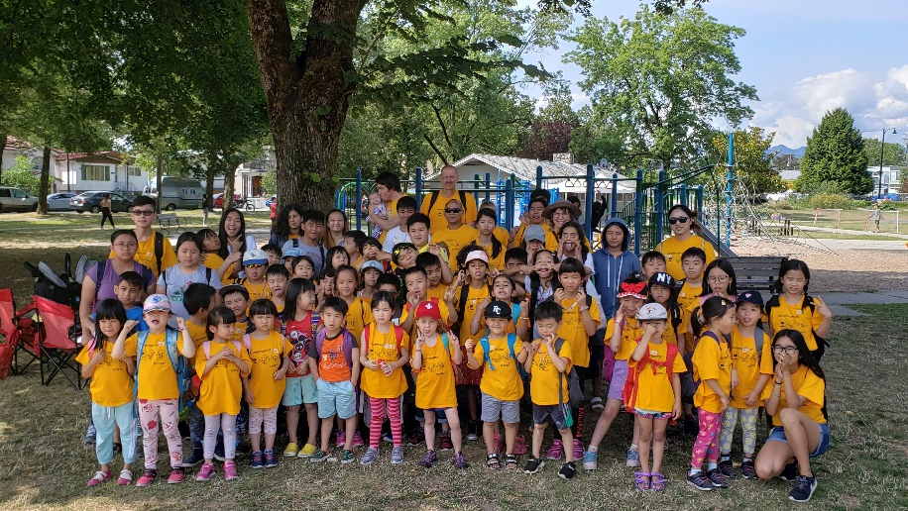

We were excited to welcome two families to BC this past week. Mohammed and Weam finally arrived from Jordan after almost four years of waiting. It was a rare treat to be at the airport and observe the hugging, laughing and tears of joy that were shed at this reunion of this family with their extended family. After that we all went to the house for further rejoicing involving food and conversation and a prayer of thanksgiving to Jesus for making this all possible. PLEASE PRAY FOR SUITABLE HOUSING FOR THIS FAMILY OR THE WHOLE EXTENDED FAMILY NEAR THE CHURCH WHICH IS THEIR DESIRE. (Left Picture)
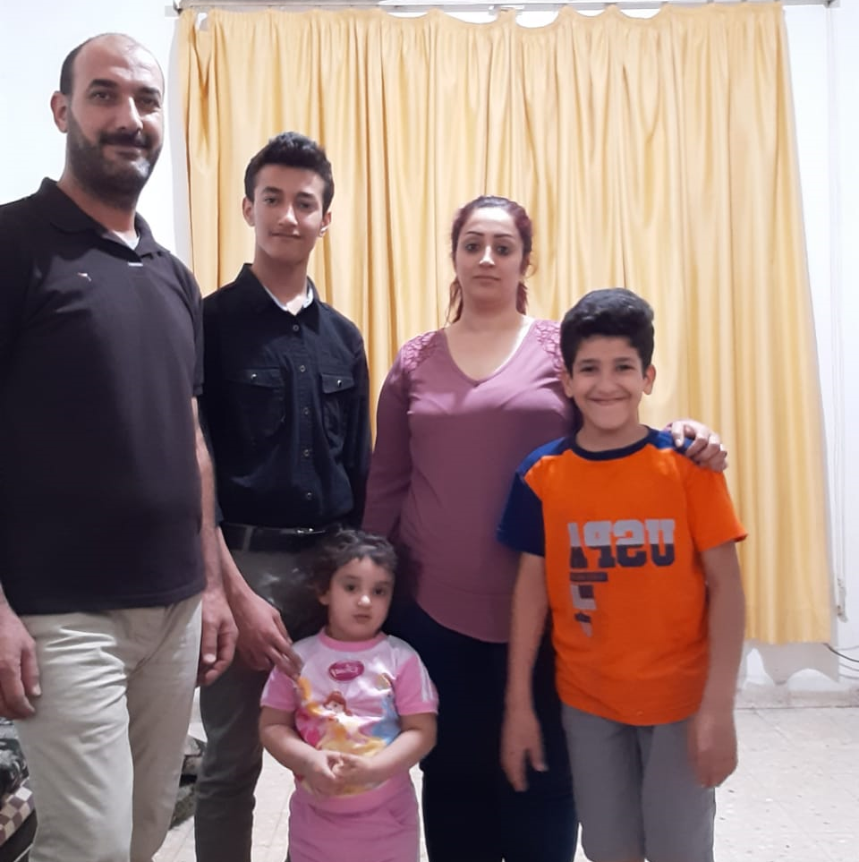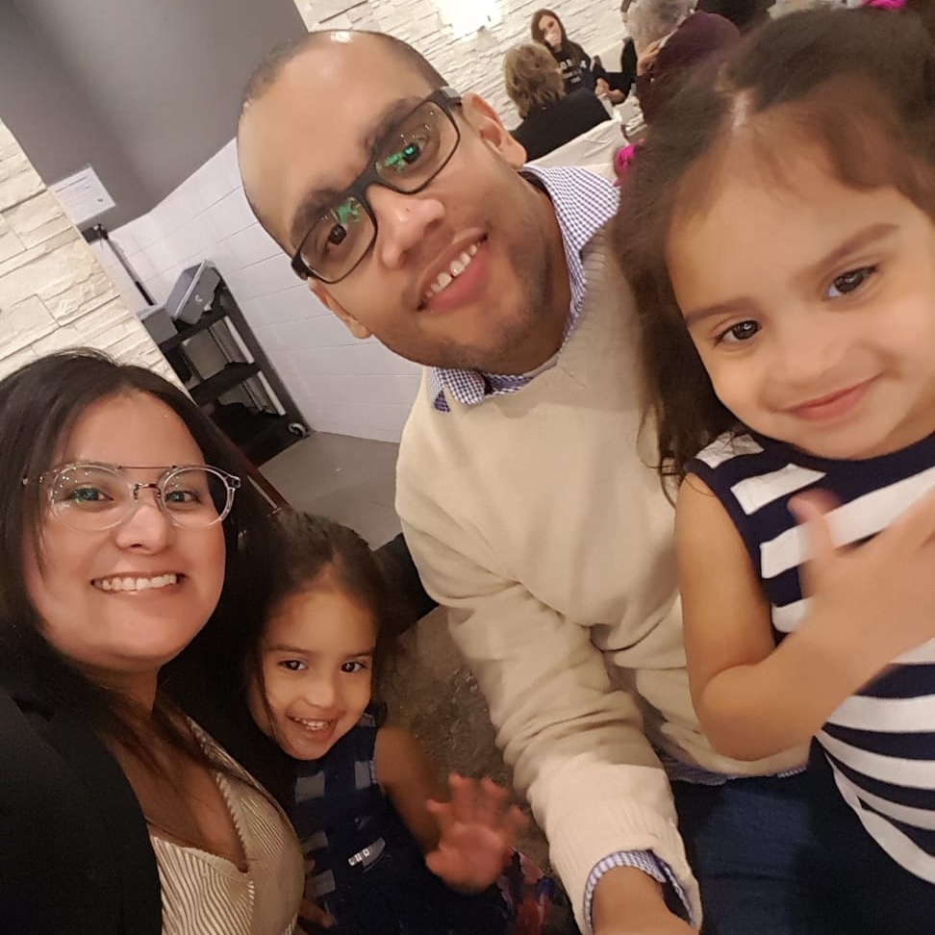
We also welcomed a family of four from Colombia who came to us via a cross- country drive from Quebec. They had a scary accident in the middle of Saskatchewan but thankfully arrived with no injuries minus their car. They are being hosted by a lovely couple in the church who have welcomed their new status of Grandpa and Grandma. PLEASE PRAY FOR SUITABLE HOUSING FOR THIS FAMILY NEAR THE CHURCH, A REPLACEMENT VEHICLE, A DAYCARE, EMPLOYMENT AND ESL SERVICES. (Right Picture)
Catherine has had a busy summer facilitating an exciting and
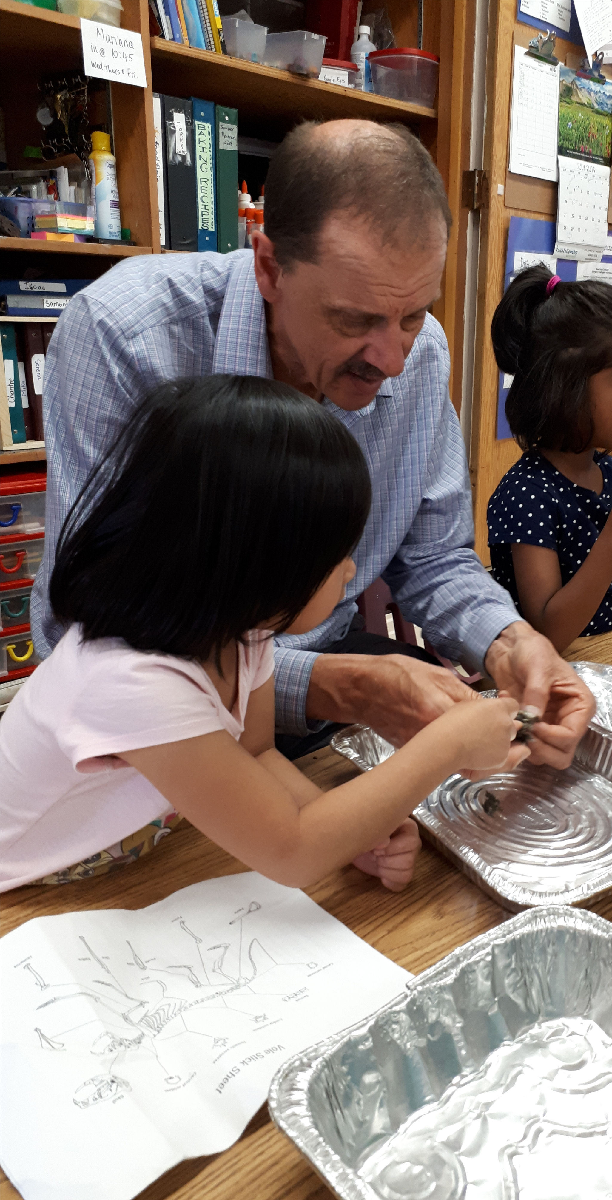
interesting summer program for the daycare children.
Highlights included an airport tour, rescue owls, Build a
Bear, ethnic food, salmon hatchery, Kitsilano beach,
soapstone carving, First Nations guest speaker etc.
(Here Mark is dissecting an owl pellet to see what it ate)

Thank you so much for your faithful prayer and support.
Blessings: Mark and Catherine

