CARDONA UPDATE JUNE 2019

Here we are, 27C, in Medellín. Beautiful day, lots of traffic and smog. Grateful, and blessed, with all sort of challenges when trying to share the Gospel with Colombians, while training godly leaders for the kingdom work.

We are searching for a place to start Sunday morning services in our latest Church Plant (Copacabana), 40 minutes north of Medellín, Colombia. It is a very religious town (80.000 people) in need of the Gospel of Grace of our Lord Jesus Christ. Please pray for this, since it has been very difficult and expensive to find a rental place for this thriving church. Marino and Adiela, a skill full couple, who are leading this church plant have applied to several locals without success, most of the time because of the opposition of Catholics.
Please, pray that our God continues reaching out to more people with His precious Gospel of Salvation and Sanctification.
Pray for Claudia and I as we lead our network of churches El Redil (15 now) to keep the good work of church planting, social/humanitarian work among Venezuelans, and missions to 5 different people groups of Colombia. We all are instruments in the hands of our Almighty God.
Thank for your prayers and support.
Diego and Claudia.
PD:
Here are a couple of pictures of our last outreach event at Copacabana Central Park.
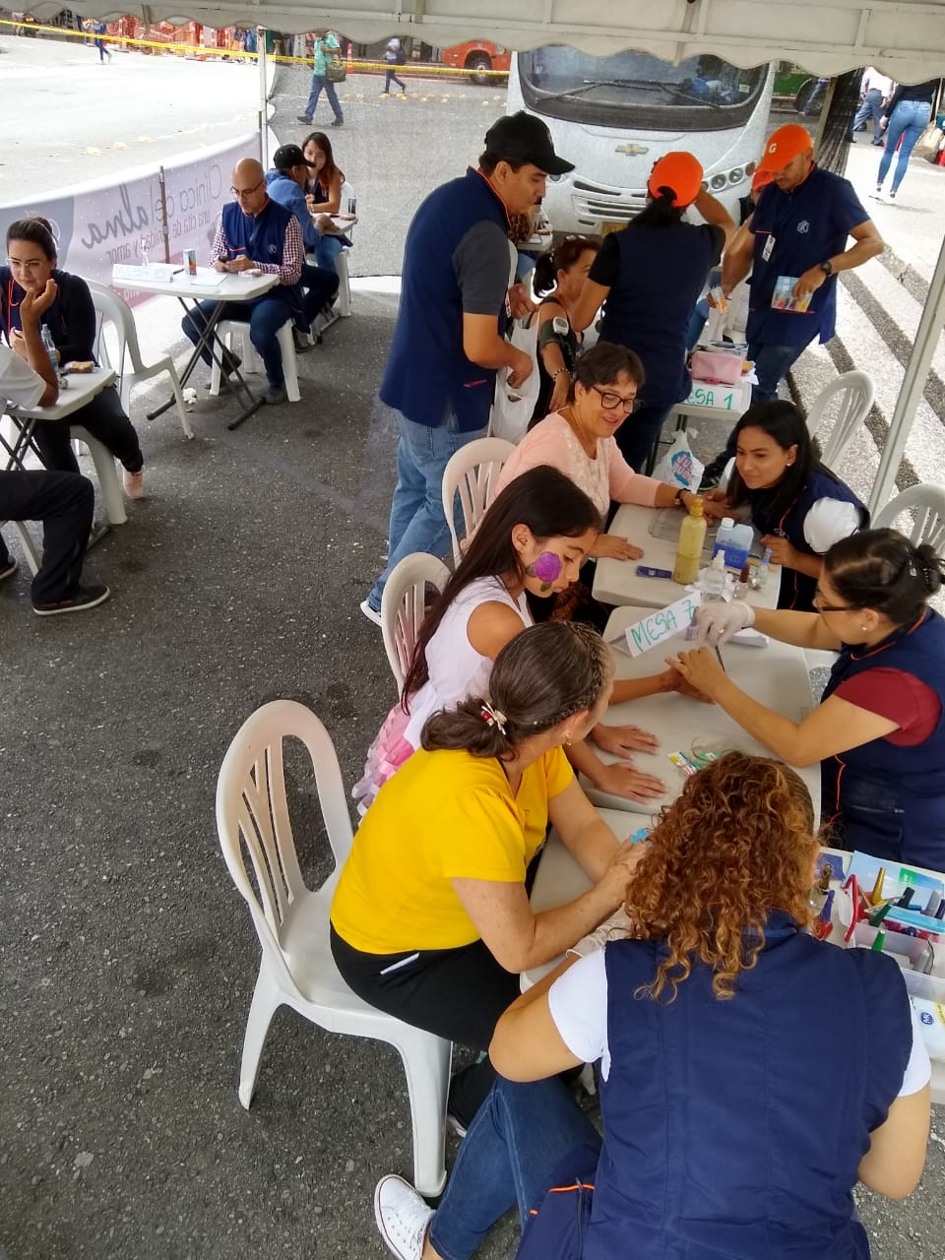
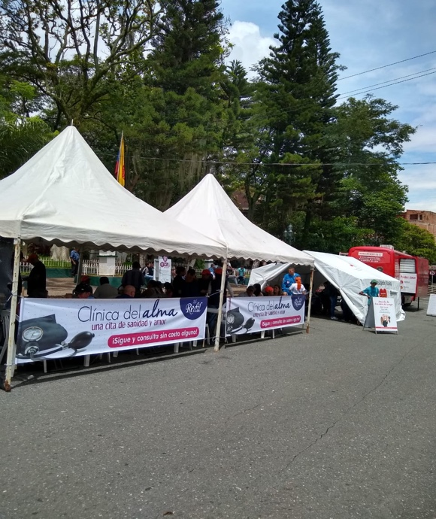

Diego and Claudia Cardona
Associate Missionaries,
Fellowship International Ministries, Colombia

