Polish
Lien
December 2018
Link
The
Polonais
Le

Greetings from Poland !
« ⁵ The LORD is gracious and righteous; our God is full of compassion.
⁶ The LORD protects the simplehearted; when I was in great need, he saved me.
⁷ Be at rest once more, O my soul, for the LORD has been good to you.
⁸ For you, O LORD, have delivered my soul from death, my eyes from tears, my feet from stumbling,
⁹ that I may walk before the LORD in the land of the living.” (Psalm 116:5-9 NIV)

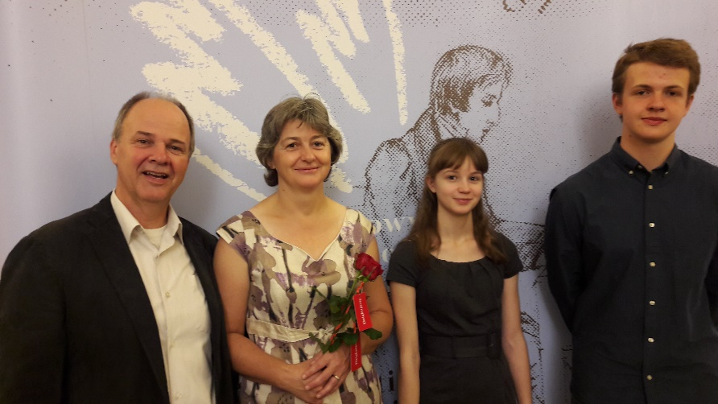
The verse above is from my personal devotional time with the Lord today. In a discipleship group of men in the church, we are studying the topic of “Worship” this month. Amazing to see the importance of worship, especially as we all read the Psalms! We learn that the important basis for a genuine worship is to know who our Lord is, and how we can then express to Him our hearts in adoration, thanksgiving, joy, songs, offerings – all in order to bring more glory to Him! In any case, this passage above reminded me of the goodness and compassion of the Lord for us. Just 4 days ago, as we were driving quite a bit for different needs, the Lord protected us from 2 major accidents. He did ‘deliver my soul from death, my eyes from tears… so that we may (continue to) walk before the Lord in the land of the living’. We give praises to Him, He is alone our Fortress and Deliverer. He deserves all that we have, since He gave and is preserving what HE has given us. Take time to praise Him for this protection and for what He does provide for you, including the fact that you still live today!

I realise that I am writing this letter after months of silence. I have no excuse, but I need to say that the months of April to September were the busiest months we ever had since we have been in Poland. Somehow, we saw many needs for prayer, serious Bible reading, visiting. There are also opportunities for ministry and did help to organise, lead, train, pray, teach in order to see the cause of the Lord Jesus Christ go forward in Poland. We had time to go to an excellent Frederik Chopin Music Competition – the reason for the family picture above! Our kids are changing so much, please for their faith, they are also gifted musicians, for which we praise the Lord.
Let’s look at some of the last months’ events one ministry at a time.
SUMMER MINISTRY 2018
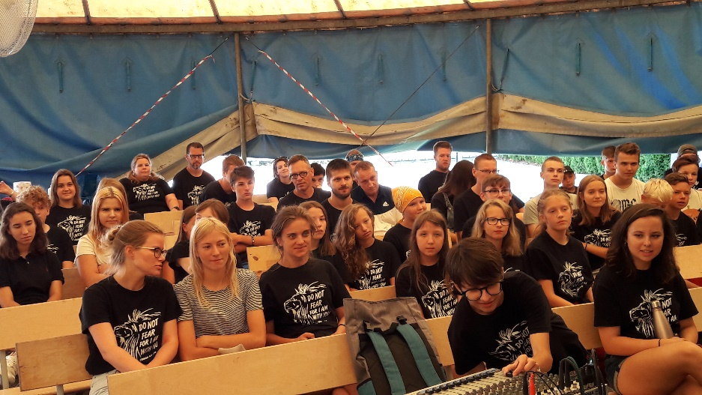
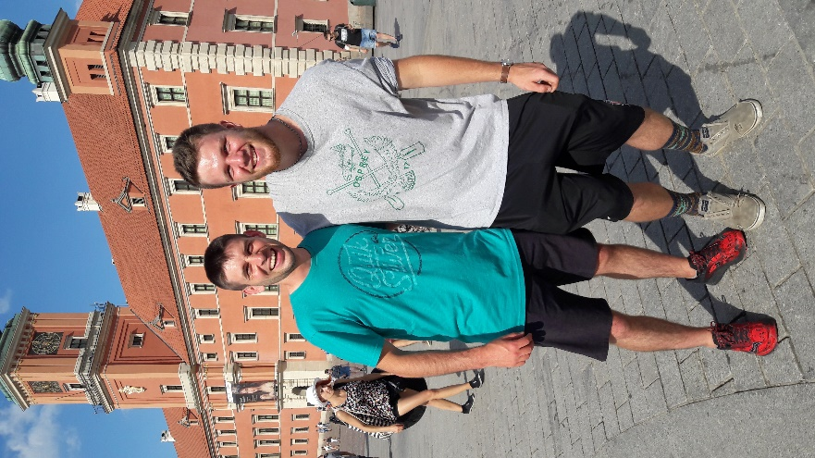
We had a great Kids Camp and our second English Camp in Zamość in August. Wonderful time of games and communicating biblical stories and truths to many kids and youth. It was wonderful to have the help of many Canadians, including the Hamm family from Southridge Baptist (Langley, BC), Jessica and Daniel Fenske from Cloverdale Baptist (Surrey, BC), and from Sam and pastor Dave Symons from Pembroke Baptist (ON) – on picture on right.

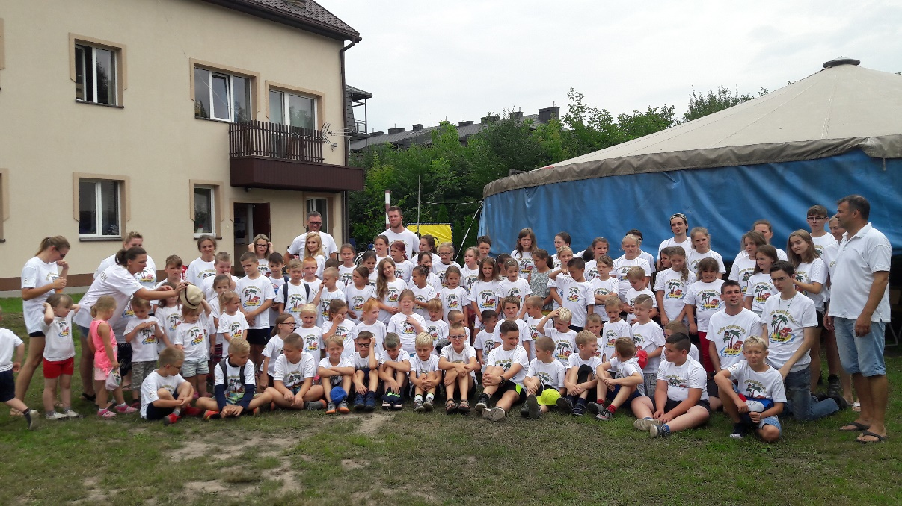
Above: English Camp for 13-20 years old

On right: Our group at Kids’ Camp, the largest the church has ever had!

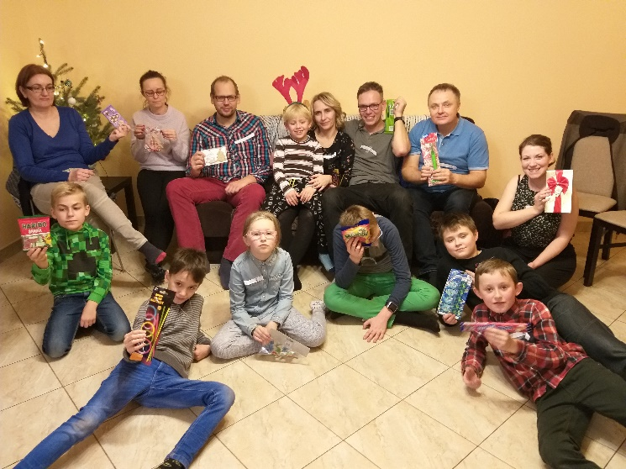
CHURCH MINISTRY 2018

We had last week the Christmas event led by Daniel and Jessica Fenske, missionaries with us in Poland. They are doing an amazing job in leading a Kids’ Club in English and providing such a natural way to be in touch with new families. All have come for that event in their home, and we pray that they will all come for our Christmas event at church this Sunday! Pray with us. We share the Gospel with them as we can. This is key time to see how the Lord can bring to faith these 3 families whose kids are coming very week to the Club.

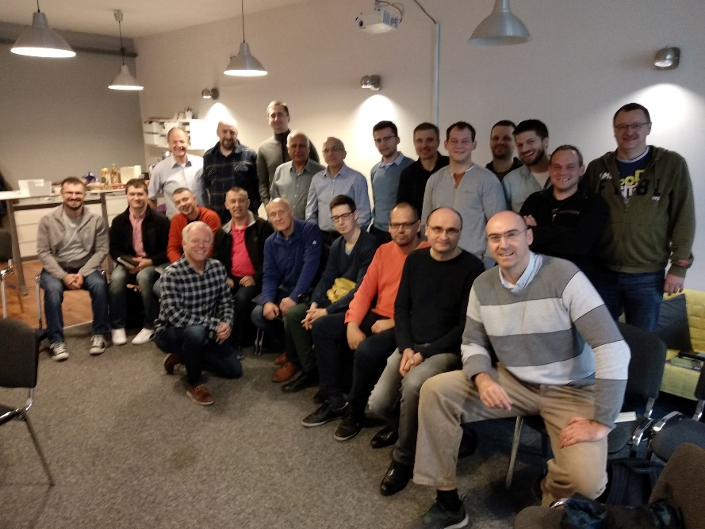
There is also an exciting project in our church right now - the Timothy Leadership Program. We have 24 men who have registered for a 2-year program where we will be looking at 20 different topics important for our faith, for the Church of Christ and for our service for the Lord. Because of the material situation of many, we provide at low costs key books for them to read, one a month. We are working at translating more key books and provide good resources in Polish to men who are just so willing to learn and grow in their faith. Could you please pray for that need? We will have our 4th meeting this Saturday (tomorrow!), on the theme of Worship. So important!

Pray for ….
Dec 15 – Timothy program with men, at Warsaw church. PRAY for discipleship.
Dec 15 – Youth Christmas evening, our first one ever! PRAY for discipleship.
Dec 16 – Kids Christmas program, at our church service on Sunday Dec 16th ! PRAY for great joy and encouragement from knowing and telling the story of Jesus!
Jan 18-19-20 – Timothy program with men, Marriage Conference on “Manhood and Womanhood – does our God make a difference?” at our Warsaw church. PRAY for transformation.
THANK YOU for being partners with God and with us in our work in Poland.

MERRY CHRISTMAS TO ALL!
MAY HIS SPIRIT bless you in worshiping of our King!
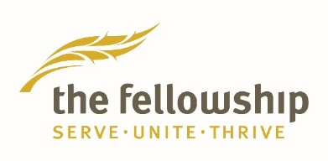

Pierre & Hanna Jutras
Servants with The Fellowship, International Ministries
Warsaw, Poland
E-mail: hanna_pierre@hotmail.com
Skype: hanna_pierre
Address: ul. Landwarowska 6A, 03-107 Warsaw POLAND
IN PRAYER & IN PICTURES ….

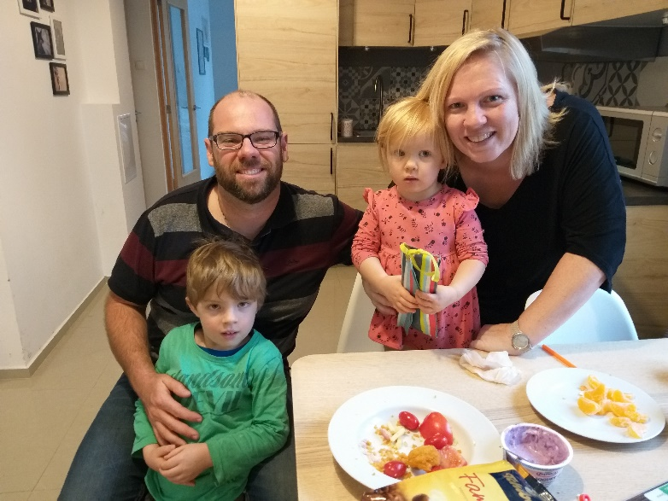

We had the visit of w wonderful godly family from Australia. What a surprise! They are looking at moving, working and serving the Lord in Poland. PRAY for their direction.

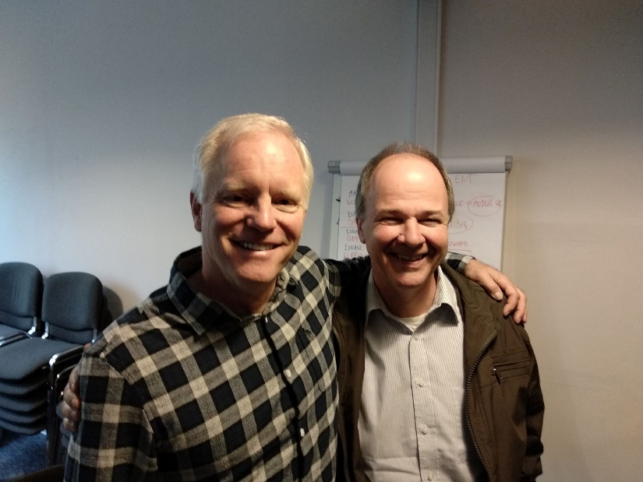
God is sending some powerful help! At our Timothy Leadership program at our church, the Lord was so gracious to give us Tim Savage, an excellent pastor and book writer, now living in England. He came to Poland to teach us about the Church, the Precious and Gifted Body of Christ! It was so powerful, the best exposition of Ephesians 4.7-16 I have ever heard in my life! Praise the Lord! PRAY for the future our discipleship with men – 2 Tim 2:2 + 3.16-17!

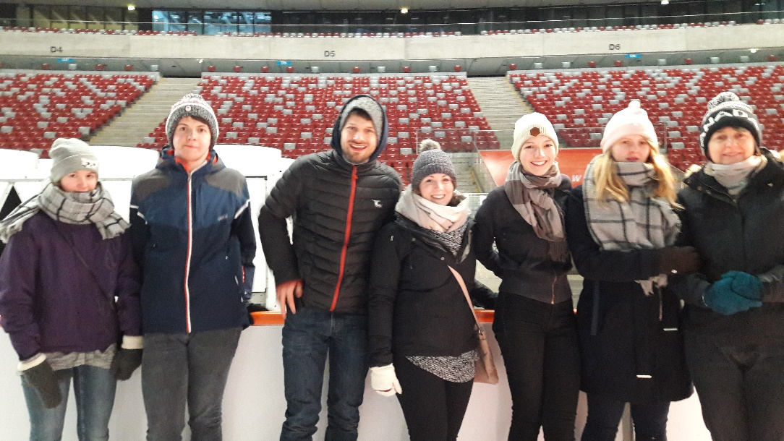

Youth meeting at the National Stadium in Warsaw – for skating! What a great time!
For our youth in church, so find great motivation to love the Lord and have meaningful friendship and fellowship.

We appreciate SO MUCH the help of Jessica & Daniel Fenske, serving with us for one year in Poland. PRAY for them – Kids’ Club, Youth ministry, and Camps.

