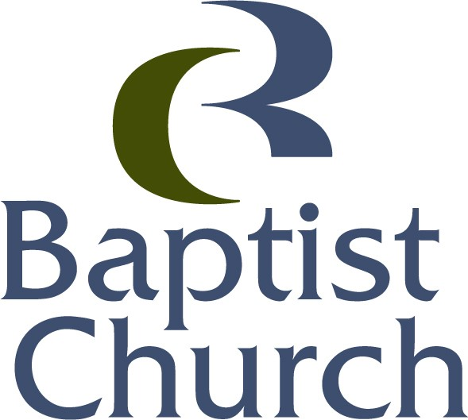 Pre-Authorized Debit (PAD) Agreement

I want to support Campbell River Baptist Church through regular giving.

My banking information is as follows (or a void cheque is attached).

Bank # ________ Branch # ______________ Account #________________________

Please withdraw $ ________________ from my bank account
Weekly – every Monday 1st of each month
Bi-Weekly–every second Monday 15th of each month
10th of each month 30th of each month (28th February)

Name
Address
City Prov Postal Code
Telephone Email Address

Comments

Signature
Date ______________________________________

I may revoke my authorization at any time, subject to providing notice of 10 days. To obtain a sample cancellation form, or for more information on my right to cancel a PAD Agreement, I may contact my financial institution or visit www.cdnpay.ca

Campbell River Baptist Church
260 South Dogwood Street
Campbell River, BC V9W 6Y7
Telephone 250-287-8831, Fax 250-287-8858 email bookkeeper@crbaptist.bc.ca

I have certain recourse rights if any debit does not comply with this agreement. For example, I have the right to receive reimbursement for any debit that is not authorized or is not consistent with this PAD Agreement. To obtain more information on my recourse rights, I may contact my financial institution or visit www.cdnpay.ca

