Greetings from Vancouver! September 2016
As some of you know, we are on holidays and enjoying the beautiful coastal sights of Sechelt, Bowen Island and Whistler, thanks to family and friends.
Being away always gives us time to reflect on the past year and catch up on correspondence. I came to the realization our family has faced a lot of change/transition over the past year and a half:
- May 2015 April and JC were married
- June 2015 Maggie was born
- October 2015 Lloyd started a new job with Amazon
- January 2016 JC took on a new role as small business loan manager with Bank of
Nova Scotia
- February 2016 Catherine was laid off from her job at Beulah Garden Homes
- February 2016: mid We moved to a different location in Vancouver
- February 2016: end April and JC moved to a different location in Vancouver
- April 2016 Nilam was born
- June 2016 Catherine started a new job with New Hope Childcare as Coordinator
- September 2016 Austin began kindergarten
- September 2016 Jonathan began an internship in leadership with Coastal Church in
Vancouver
- October 2016 We celebrate our 37th anniversary
Change and transition have been a part of our lives as missionaries in Kenya, travelling back and forth for home assignments, people transitioning in and out of RVA over the 20 years we lived there, living in many different homes and I don’t know how many different cars we drove during furloughs! We always had a roof over our heads and a car to drive!
Two things have remained constant over all these years:
- God has remained faithful through the journey.
- You have been part of our team throughout the many years we have served both in Kenya and Vancouver. Words cannot express how grateful we are for your faithfulness to our family and ministry.
Know you are appreciated!
Serving together in our great city of Vancouver,
Mark and Catherine

PS See updated pictures of grandkids below

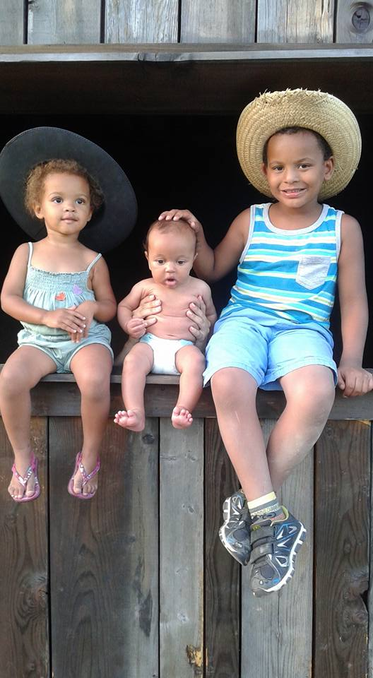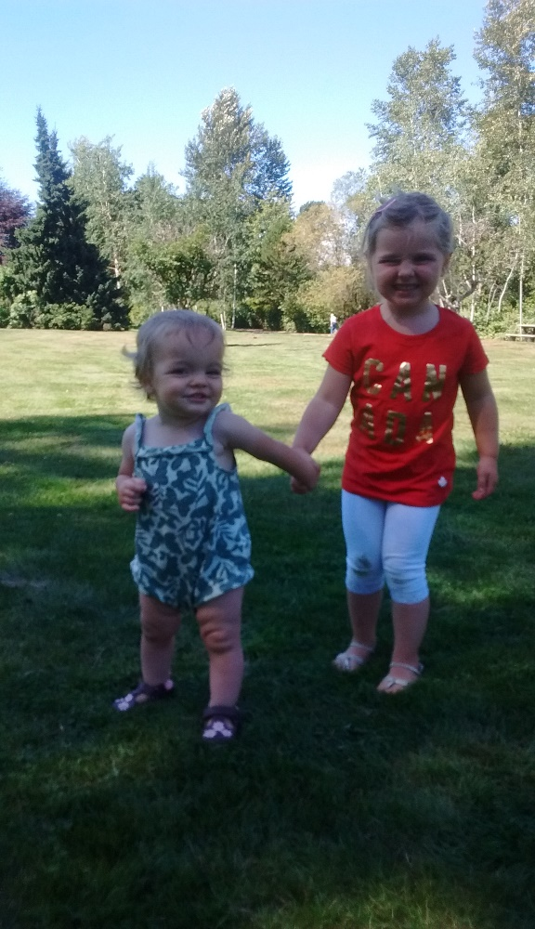

Kora (2 ½ yrs), Nilam (4 mns), Austin (5 yrs) Alida (3 ½ yrs), Maggie (1 yr)

